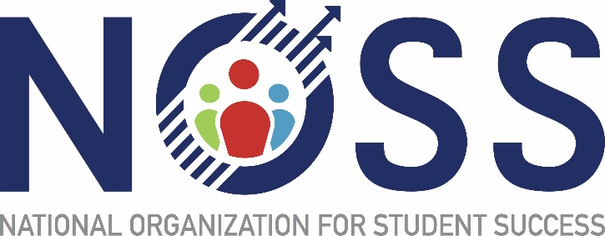

Conference Manager: Annette Cook
Exhibits Coordinator: Mary Zimmerer, Chandler-Gilbert Community College (2020-2023)
Marketing Coordinator: Johari Barnes, Comm. College of Baltimore College (2020-2022)
Program Coordinator: Amy Tankersley, Pellissippi Community College (2022-2024)
Registration Coordinator: Bea Houston, Western Iowa Technical Community College (2022-2023)

